TEST RESULT
- CRR-TC-01: User Identity Capture Verification
Objective:
To verify that the system securely and accurately captures the actual Windows username of the person running the application. This ensures that the Audit Trail history is always linked to a real person.
Procedure:
- Source Code Navigation:
- Open the project repository in a code editor (e.g., VS Code).
- Navigate to the file `audit_trail.py`.
- Logic Verification:
- Locate the `log_event` function definition.
- Verify that the system is programmed to ask Windows for the current user (`getpass.getuser()`).
Acceptance Criteria:
- The code explicitly imports and utilizes the correct module to securely identify the user.
Results:
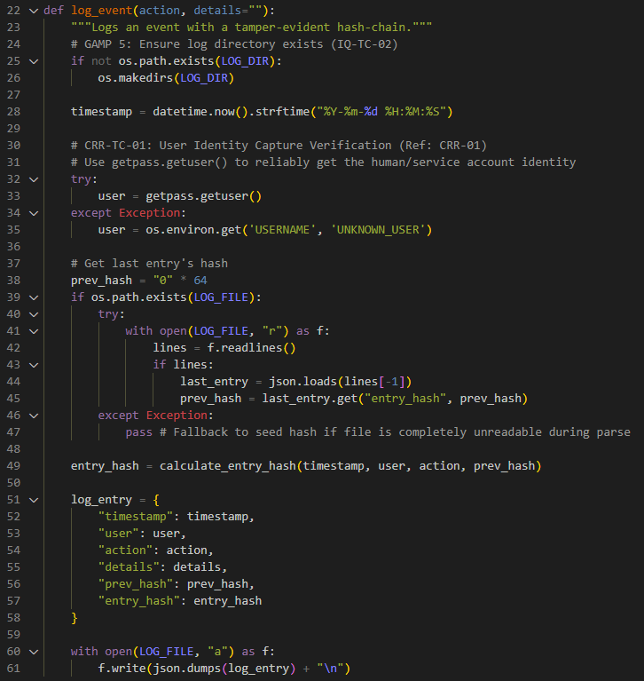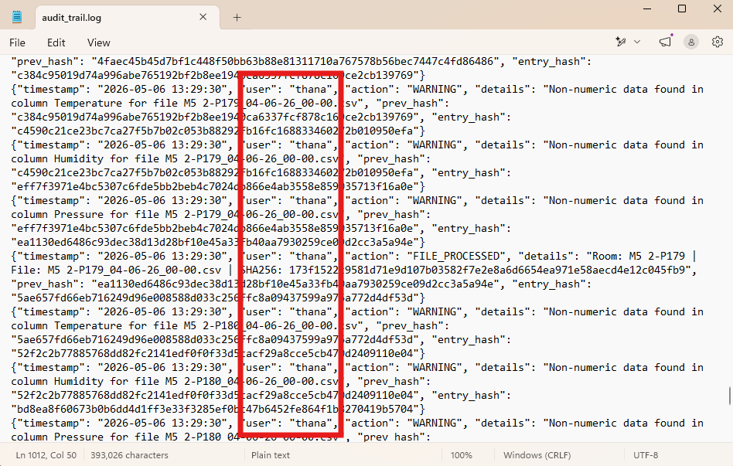

- CRR-TC-02: Temporal Alignment Logic Verification
Objective:
To verify that the system aligns time-stamps properly when comparing pressure between two rooms, allowing a small 60-second window (tolerance) to account for slight delays in different sensors sending their data.
Procedure:
- Source Code Navigation:
- Open the project repository in a code editor.
- Navigate to the file `analysis_logic.py`.
- Logic Verification:
- Locate the `check_reverse_violations` and `analyze_files` functions.
- Find the data joining function (`pd.merge_asof`) used for pressure corridor comparisons.
- Verify that the system is instructed to find the "nearest" time within a strict 60-second maximum limit (`tolerance=pd.Timedelta('60s')`).
Acceptance Criteria:
- The code utilizes the "nearest" direction rule to handle minor sensor timing issues (sensor jitter).
- The time limit is strictly set to 60 seconds to prevent the system from comparing pressure data from completely different times.
Results:
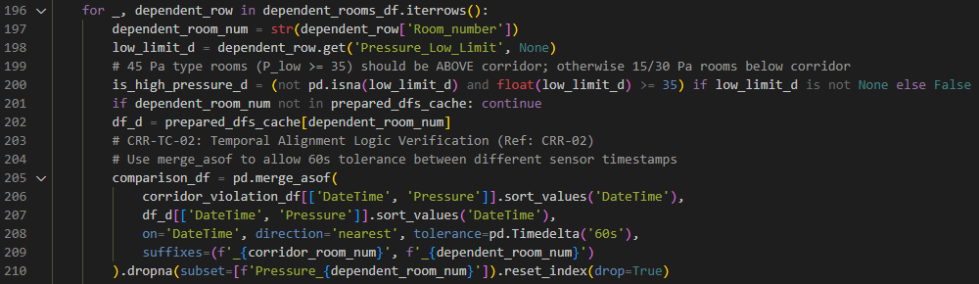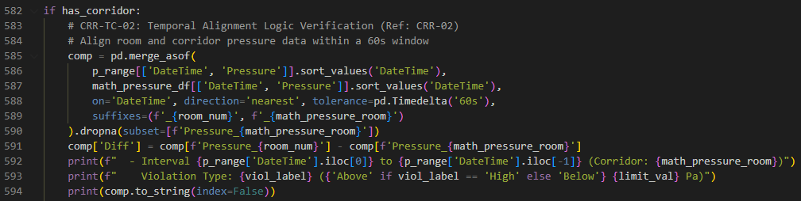

- IQ-TC-01: Binary Integrity & Versioning Verification
Objective:
To verify that the delivered program (`AirQualityReview.exe`) is correctly installed, matches the officially validated software build, and contains the correct version information.
Procedure:
- System Installation:
- Locate the source installation package (the standalone program).
- Copy the `AirQualityReview.exe` file and its associated data folders to your local computer drive (e.g., `C:\AQR_System\`).
- Navigation and Metadata Verification:
- Open Windows File Explorer.
- Navigate to the directory where you copied the application.
- Right-click on the file `AirQualityReview.exe`.
- Select 'Properties' from the menu and navigate to the 'Details' tab.
- Verify the "Product Version" field.
- Command-Line Integrity Check (SHA-256 Checksum):
- Press the `Windows + R` keys to open the 'Run' dialog box.
- Type `powershell` and press Enter.
- In the PowerShell window, type: `cd C:\AQR_System\` (or your actual path).
- Type the command: `Get-FileHash .\AirQualityReview.exe -Algorithm SHA256 | Format-List`
- Comparison:
- Compare the digital fingerprint (Hash value) displayed on your screen against the Master Build Record.
Acceptance Criteria:
- Product Version explicitly displays "v1.1.0".
- The generated SHA-256 hash perfectly matches the Master Build Record: `D12E959AC43FC8E69CC04C64ED1BFFFBFFE71EDE2CEDCB976A320DD6A113023E`
Results:
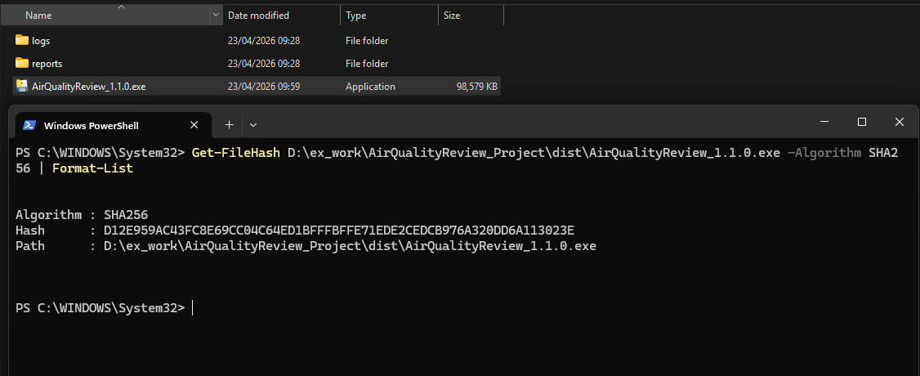

- IQ-TC-02: Directory Structure Verification
Objective:
To verify that the system successfully sets up its own working environment by automatically creating the necessary folders and the core security log file the first time you run it.
Procedure:
- Initial Execution:
- Navigate to the application root directory (e.g., `C:\AQR_System\`).
- Double-click `AirQualityReview.exe` to launch the application for the first time.
- Wait for the visual dashboard (Graphical User Interface) to appear.
- System Shutdown:
- Close the application browser window and stop the program if necessary.
- Visual Inspection:
- Using Windows File Explorer, inspect the contents of the application root directory.
- Verify that the system has newly created two folders: `./reports` and `./logs`.
- File Verification:
- Enter the `./logs` folder.
- Verify the presence of the `audit_trail.log` file.
Acceptance Criteria:
- The `./reports` folder is automatically generated and present.
- The `./logs` folder is automatically generated and present.
- The `audit_trail.log` file is successfully initialized and located securely within the `./logs` directory.
Results:
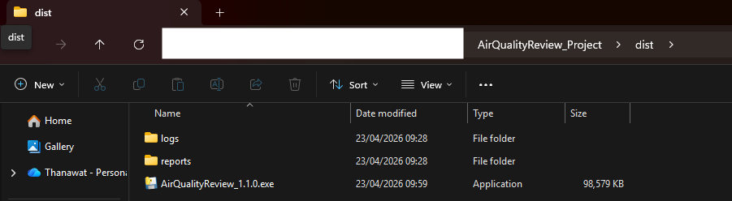
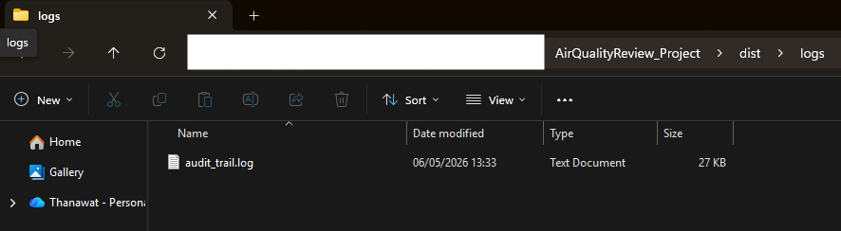

- IQ-TC-04: Automated Folder Initialization
Objective:
To verify the system's ability to "self-heal". If critical folders are accidentally deleted by a user, the system must be able to automatically recreate them to prevent crashing.

Procedure:
- Environment Preparation:
- Navigate to the application root directory.
- Ensure the application (`AirQualityReview.exe`) is completely closed.
- Simulation of Missing Components:
- Select the `./logs` folder and delete it entirely.
- Select the `./reports` folder and delete it entirely.
- Confirm both folders are removed from the root directory.
- System Re-initialization:
- Double-click `AirQualityReview.exe` to launch the application.
- Observe the startup process to ensure no error messages appear.
- Verification of Self-Healing:
- Switch back to Windows File Explorer and inspect the root directory.
Acceptance Criteria:
- The application launches successfully without displaying any system errors.
- The system automatically re-creates the missing `./logs` and `./reports` folders to restore functionality.
Results:
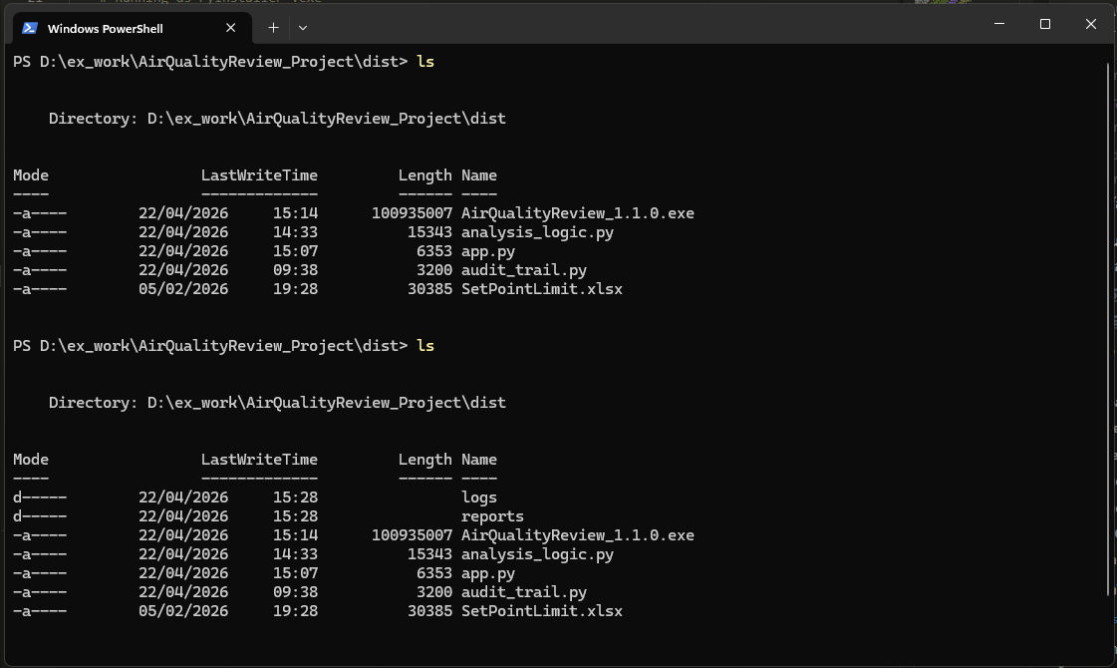

- IQ-TC-06: Pre-Flight Integrity Check Failure
Objective:
To verify that the system has a robust self-protection mechanism. It must prevent the program from opening if it detects that the security history file (`audit_trail.log`) has been manually altered, ensuring compliance with strict data security rules (21 CFR Part 11).
Procedure:
- Preparation:
- Navigate to the `./logs` directory.
- Right-click the `audit_trail.log` file and select 'Open with Notepad'.
- Simulation of Unauthorized Modification (Data Tampering):
- Identify a single character or a long hash string in the text.
- Manually edit or delete characters (e.g., change a specific letter or number).
- Save the changes and close Notepad.
- System Execution Attempt:
- Return to the root directory and double-click `AirQualityReview.exe`.
- Verification of System Halt:
- Confirm the main visual dashboard does not open.
- Verify the exact wording of the error message displayed on the screen.
Acceptance Criteria:
- The application must refuse to start and immediately halt all internal processes.
- The system must display a fatal error message exactly reading: "FATAL ERROR 004: Audit Trail Integrity Check Failed".
- Details inside the error message must mention the security violation or tampered entry.
Results:
